HS017
HS Risk management form
For additional information refer to HS329 Risk Management Procedure

Faculty/Division: Arc Clubs |  |  | School/Unit OR Arc Club/Society:
Document number 1 | Initial Issue date 11/03/2021 | Current version 1 |  | Current Version Issue date: 2021 | Next review date

Risk management name | BBQ Event by Arc affiliated Club - 2021

Form completed by |  | Signature | Date
Responsible supervisor/event manager |  | Signature | Date

Identify the activity and the location of the activity:  Use of one of the electric built-in BBQs or a portable gas BBQ, by student/staff groups:  - Michael Birt Lawn (D25)  - Library Lawn Gravel Area (E21) – built-in electric BBQ  - Morven Brown Lawn (C20)  - Commerce Courtyard CLB (E20)  - Ball Sculpture Lawn (H17)  - Chancellor’s Garden – Fountain OMB (J15) – built-in electric BBQ  - Physics Lawn (L13) – built-in electric BBQ  - Science Theatre Lawn (G13)  - Alumni Park Lawn (D12)  - Sam Cracknell (H8) – built-in electric BBQ | Identify who may be at risk from the activity:  A number of people may be at risk from any activity held on the day, inclement weather and by attending the event. This may affect the risk controls needed and will be actioned as requested. All people onsite are included and extend to fellow workers, visitors, contractors and the public. The location of the activities may affect the number of people at risk. This event is a showcase of Uni with public displays, activities and information.  How were people consulted?  Consultation, site inspections, meetings, previous documents, staff experience and knowledge, resources, legislation, NSW Worksafe website and resources, training courses and material content
List legislation, standards, codes of practice, manufacturer’s guidance etc used to determine control measures necessary
Work Health and Safety Act 2011
Work Health and Safety Regulation 2017 Codes of Practice

Identify hazards and control the risks.
- An activity may be divided into tasks. For each task identify the hazards and associated risks. Also list the possible scenarios which could sooner or later cause harm.
- Determine controls necessary based on legislation, codes of practice, Australian standards, manufacturer’s instructions etc.
- List existing risk controls and any additional controls that need to be implemented
- Rate the risk once all controls are in place using the matrix in HS329 Risk Management Procedure
Task/ Scenario | Hazard | Associate  d harm | Existing controls | Any additional controls required? | Risk Rating |  |  | Cost of controls (in terms of time, effort, money) | Is this reasonably practicable  Y/N
 |  |  |  |  | C | L | R
Infected Volunteers attends event | Other volunteers/ participant contract COVID-19 | Physical Sickness | - Active area is outdoors to provide enough space to allow for social distancing to be maintained.  - All volunteers have completed a “Safe return to campus”  agreement.  - Volunteers will sanitise and clean BBQ areas, and any equipment before and after each shift using the appropriate technique and guides.  - Volunteers will also be instructed to wear masks whenever they are unable to maintain social distancing measures for a prolonged period, or if interacting with attendees.  - Volunteers will also wash their hands before and after helping  with the BBQ.  - Volunteers are made aware of the COVID Safety plan to properly understand what actions would be required to be taken if a volunteer is present with symptoms and is marked as a potential case of COVID-19.  - List of all equipment that is used and shared and are properly  instructed to thoroughly clean equipment before and after using the appropriate guide.  - Hand sanitiser will be provided to ensure all items are properly  sanitised. | N/A

Persistent Use of Face Masks | Potential irritation, bruises or cuts around the mask area | Physical Injury | - Club executives and volunteers are instructed that masks should be worn when physical distancing measures cannot be adhered to (1.5m distancing), or if a patron-facing position.  - Club executives and volunteers are also trained on how to correctly put on and take off masks and to remove them when not necessary. | N/A
Persistent Use of hand sanitiser | Dermatitis | Physical Injury | - volunteers are encouraged to wash their hands with soap and water where possible as an alternative to hand sanitiser.  - Volunteers are trained in how to effectively use hand sanitiser to avoid excessive use.  - Ask volunteers if they have a history of dermatitis or an allergy to alcohol, and provide PPE (i.e. gloves) if they do have these allergies. | N/A
Infected community member (participants & general public) attends event | Other helpers/ participants contract COVID-19 | Physical illness | - Ensure that Active area remains outdoors to that participants will have enough space to maintain social distancing.  - Participants will be reminded of COVID Safety and precautions.  - Participants are instructed not to attend this event if they are unwell, even if they feel fit enough to participate. In communicating this, participants are provided with a link to COVID-19 symptoms.  - Communicate to participants that they should not participate in this event if in the last 14 days they have been feeling unwell (experienced any symptoms regardless of the severity) or have visited a reported case location. Participants will be required to notify the club if they develop any symptoms or are tested for COVID-19.  - Volunteers will implement the COVID-19 safety plan if any participant is visibly unwell/ displaying symptoms whilst on the premises. | N/A

 |  |  | - Participants will be instructed to wear face masks when they are unable to maintain social distancing measures for prolonged periods of time when facing each other.  - Cones, markers or barricades will be assembled in appropriate areas to appropriately mark 1.5m distancing to ensure distancing procedures are maintained from food and the BBQ.  - Hand sanitiser will be provided at entry points to the event and will require participants to apply before they are allowed to enter or participate in the event.  - Contact between others will not be permitted such as shaking hands, hugging, high-fives etc.  - Directions to wash/sanitise hands before and after participating, as well instructional material on to how to do so properly will be given.  - Provide guidance/ appropriate resources for self- quarantine/precautionary measures.  - If a participant has been diagnosed with COVID-19 in the past, they can only participate if they demonstrate evidence of doctor clearance and have satisfied the Communicable Disease Network of Australia (CDNA) criteria to ensure that they are no longer infectious.  - When registering, participants must declare if they are a high- risk participant.  - Discussion with higher-risk participants regarding participation of this event will be dependent on the circumstances. Solutions to ease this would be restrictions or prohibiting the participation of this event.  - Volunteers will maintain an updated list of all participants attending this activity along with their appropriate entry and exit time and location. | N/A
Participants come into contact with infected passerbys | Other staff or participants contract COVID-19 | Physical Illness | - Recommend participants to download the COVID-19 safety app.  - Ensure all participants sign in to COVID tracking for the event | N/A

Food preparation | Raw meat, contaminated surfaces, Raw and ready to eat food coming into contact during food preparation, contaminated food | Food poisoning, negative student or patron experience, damaged university reputation | - No self-service for any food or drink.  - Anyone cooking or handling food to provide to attendees must be wearing a mask and gloves. Any helpers near uncovered food items also need to wear masks.  - Food items are to be stored away from participants (e.g. a table with uncovered food items should be behind the servers, ideally with another table between the servers and participants).  - Food must be handed out as individual portions, participants must not share the food or utensils they have received.  - Avoid handing items back and forth between servers and  participants. If you are handing someone a second serving, use a fresh plate/napkin rather than reusing their existing one.  - Food must still be sourced from a professional supplier/caterer (i.e. clubs cannot cook their own food). An exception is that BBQ ingredients that are store-bought may be cooked by clubs on campus.  - Purchased food to be within use-by dates.  - All meat to remain frozen during storage.  - Separate chopping boards and utensils to be used when preparing meats and salads/ready to eat food.  - Separate utensils for cooked and raw meats.  - Observe good hygiene standards, hands must be washed between handling uncooked meats and ready to eat foods.  - Keep salads separate from raw meats to prevent  contamination.  - Food handlers to keep cuts covered.  - Food handlers must not participate if they have had a food related illness in the last 48 hours.  - Protect food from likely contamination by customers, dust,  fumes and insects using plastic wrap covers.  - Disposable eating and drinking utensils to be used.  - Food Standards for Australia/New Zealand to be complied with. | Coordinator to sort food items-esky & sealed units of food supplied
Setting up the BBQ / Use of existing facilities | Contaminated BBQ plate, Gas BBQ:  damaged cylinder, out of date, faulty gas connection, faulty pipes, faulty taps,  wind, | Food poisoning, explosion, fire, physical injury and burns, gas leaks,  faulty equipme nt | - Inspect hot plate and if required clean prior to use.  - Visual inspection of the BBQ, gas pipes and gas cylinder for damage prior to use, BBQ not to be used if it is believed to be damaged.  - Check that the gas cylinder is in good condition and that it is within its test period for use (testing is required every 10 years)  - Check that the taps are working correctly.  - Check that the taps are turned off before connecting to the gas cylinder. | Check onsite and clean before & after use  Check all items before use  Report any issues  Students who consider smoking in

Task/ Scenario | Hazard | Associated harm | Existing controls | Any additional controls required? | Risk Rating |  |  | Cost of controls (in terms of time, effort, money) | Is this reasonably practicable  Y/N
 |  |  |  |  | C | L | R
 | maintenance and control of equipment |  | - Gas is turned off if there is a suspected gas leak.  - Gas fuse safety cut off device.  - BBQ is located away from combustibles and air intake areas.  - Check the wind direction and the weather before starting the BBQ. Do not use the BBQ if there is a concern about the risk of fire due to wind direction.  - Fire extinguishers are in all buildings.  - All students understand the UNSW Emergency Procedure for fires.  - BBQ is sited in an area free of vehicle and pedestrian traffic with access to the BBQ limited to persons operating the BBQ.  - UNSW policy prohibits any smoking on campus – there is to be no smoking, especially near a BBQ | an open air environment are reminded UNSW is a smoke-free area –
 |  |  |  | https://www.gs.uns w.edu.au/policy/doc uments/smokefreep olicy.pdf
Electrical BBQ | Electric BBQ – faulty electrical wiring | Electric shock, physical injury, negative student/patron experience, damaged university reputation | - BBQs are connected to fixed electrical supply  - Electrical connections are inspected once a year by EM  - Inspect BBQ days prior to the event & report damage/faults to Estate Management (EM) on emadminsupport@unsw.edu.au | Report any issues to EM
Fire Ban | Increased chance of | Increased chance of | - During a total fire ban, combustible material is banned from being within 2 metres of both gas and electric BBQs.  - During a total fire ban, for gas BBQs an immediate and continuous supply of water is required.
 | injury due to | explosion, fire,
 | extreme heat | physical injury
 | conditions, | and burns,
 | legal | legal
 | restrictions | compliance

Task/ Scenario | Hazard | Associated harm | Existing controls | Any additional controls required? | Risk Rating |  |  | Cost of controls (in terms of time, effort, money) | Is this reasonably practicable  Y/N
 |  |  |  |  | C | L | R
Inclement weather conditions | Extreme weather conditions | Physical injury and burns, BBQ rained out/cancelled, poor student/patron  turn out | - Check weather forecast day prior to the event to monitor extreme weather conditions that will interfere with event.  - Set-up canopy to avoid sudden or expected rain pour. | Consider cancelling the event should extreme weather conditions persist
Strong winds | Unsecured objects, debris, dust and insects spoiling food/contamin ating BBQ, wind blowing objects and equipment | Contaminated food, physical injury, burns, fire, negative student/patron experience | - Check the wind direction and the weather before starting the BBQ. Do not use the BBQ if there is a concern about the risk of fire due to wind direction.  - Ensure food is covered to protect from debris, dust and inspects.  - Ensure food is covered to protect from leaves/bark from tree.  - Ensure food is covered to protect from bird droppings.  - Ensure all objects are secured – maintaining that food is at least 150mm off ground.  - Inspect area day prior to event to ensure BBQ area is safe from falling branches, objects.
Cooking food | Hot surfaces, excess grease on the BBQ, BBQ sited in traffic routes, undercooking/ cross contamination | Burns, fire – physical injury, damage to surfaces under the BBQ, food poisoning | - Ensure BBQ is not overloaded.  - Use clean, suitable utensils to handle food.  - The BBQ is always to be attended.  - Use separate tongs/plate for raw and cooked meats  - Wash hands regularly.  - Only food which can be cooked at any one time is taken out of the cool box/refrigerator.  - Uncooked food is stored in a cool box/refrigerator.  - Turn food regularly and ensure to move it around the BBQ to ensure it cooks thoroughly  - Ensure all meat is well done and is served steaming hot  - Serve food immediately after cooking  - Dispose of all left-over food unless refrigeration equipment is available too rapidly cool the food  - Cooked food is not to be reheated | Coordinator onsite to manage  Check all items & use correct trays for food handling

Task/ Scenario | Hazard | Associated harm | Existing controls | Any additional controls required? | Risk Rating |  |  | Cost of controls (in terms of time, effort, money) | Is this reasonably practicable  Y/N
 |  |  |  |  | C | L | R
Staff handling BBQ | Staff illness, negligence or accident handling equipment, jewellery and accessories, hair | Physical injury and burns, food contamination, negative student experience | - Food handlers to remove jewellery and accessories to avoid injury.  - Food handlers to be wearing gloves/mittens and not directly contact food with hands or body.  - Food handlers to keep cuts covered.  - Food handlers & staff to avoid sneezing, blowing or coughing over food  - Food handlers to ensure they wash their hands before and after handling food.  - Food handlers not to be eating while cooking.  - Long hair to be tied back.  - Food handlers to keep cuts covered.  - Trained First aider on site.
Packing up the BBQ | Disconnecting the gas BBQ, cleaning the BBQ, Moving the BBQ – manual  handling, burns | Explosion, fire, physical injury, burns, muscular injury | - Turn off gas securely before disconnecting  - Ensure not to touch hot surfaces  - Allow for BBQ to cool before cleaning it  - Allow the BBQ to cool before moving it  - Use safe manual handling techniques to avoid muscle strain | Clean all items & BBQ area

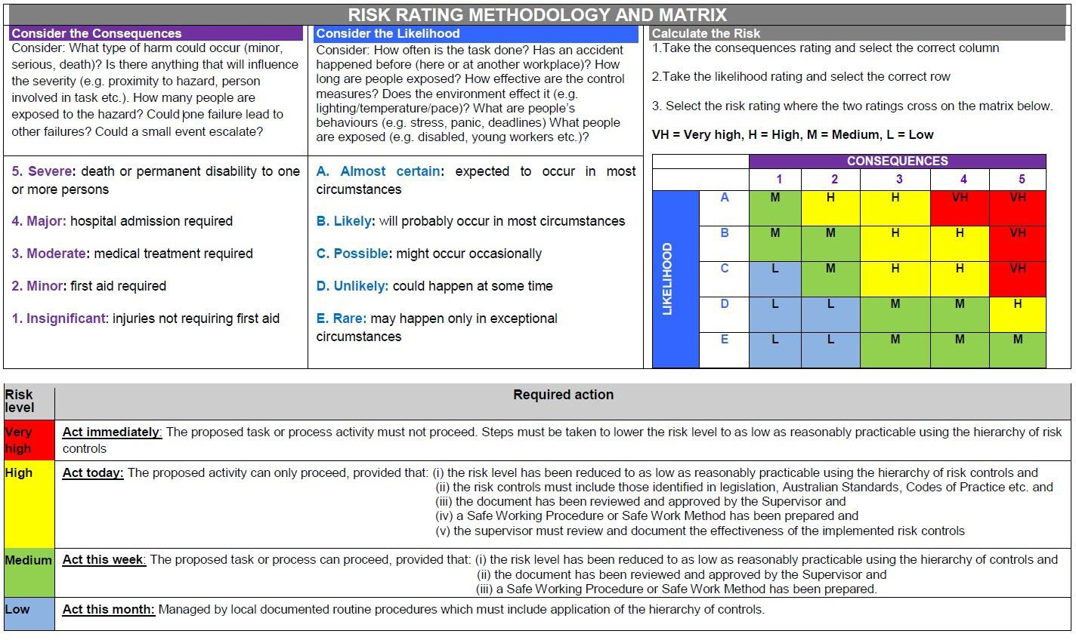

List emergency procedures and controls
List emergency controls for how to deal with fires, spills or exposure to hazardous substances and/or emergency shutdown procedures
Contact Security 9385 6666 if required for any emergency or risks noted immediately.

Implementation
Additional control measures needed: | Resources required | Responsible person | Date of implementation

REVIEW
Scheduled review date:
Are all control measures in place?
Are controls eliminating or minimising the risk?
Are there any new problems with the risk?
Review by: (name)
Review date:

Acknowledgement of Understanding

All persons performing these tasks must sign that they have read and understood the risk management (as described in HS329 Risk Management Procedure).

Note: for activities which are low risk or include a large group of people (e.g. open days, BBQ’s, student classes etc), only the persons undertaking the key activities need to sign below. For all others involved in such activities, the information can be covered by other methods including for example a safety briefing, induction, and/or safety information sheet (ensure the method of communicating this information is specified here)
Risk management name and version number: I have read and understand this risk management form
Name | Signature | Date

