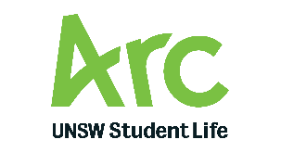 |  | SDC Meeting  Date: Insert date of meeting, eg 30 June 2020  Agenda Item: 4.2  Matter for Noting
TITLE: |  | IRC Activity Report
RESOLUTION:
The Subcommittee notes the below IRC Activity Report.
KEY POINTS:
- INSERT INFORMATION HERE / UPDATE HERE REGARDING RECENT IRC ACTIVITY. IF YOU WOULD LIKE TO INCLUDE ANY ATTACHMENTS/EVENT PROGRAMMING/SUMMARIES ETC PLEASE ADD AS ATTACHMENTS AND LIST BELOW.

BACKGROUND:
- Per the update to the IRC Charter in 2021, the IRC will now provide an ‘Activity’ Report for each SDC Meeting. This report summarises recent activity, any wins/challenges/updates. The IRC President is also invited to the SDC meetings as an optional attendee
LINK TO Arc STRATEGY: | - Get Everyone Connected, Support Every Student, Fulfil Everyone’s Needs
CONSULTATIONS: | IRC President  IRC Arc Delegate
FINANCIAL IMPACT: | - None unbudgeted
ATTACHMENTS: | Attachment 1: Title

Prepared by: Name, Title

